1. Creating Storage and then starting my container which is mounted to this volume.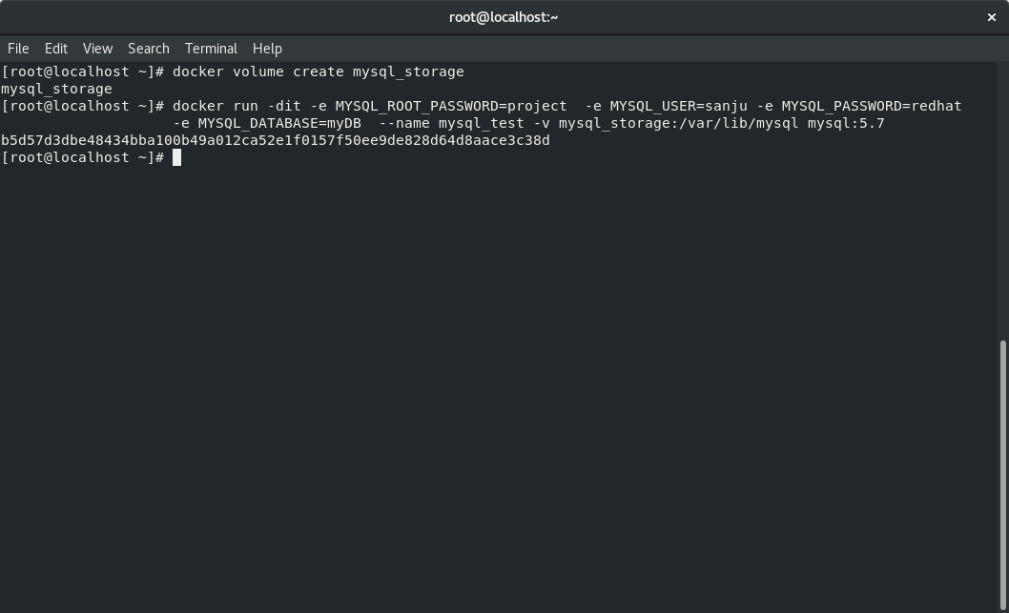

Storage_Name = “mysql_storage”

Container_Name = “mysql_test”

1. Now we create a storage for Wordpress and start our container and mount with this.

Storage_Name = “wordpress_storage”

Container_Name = wordpress_test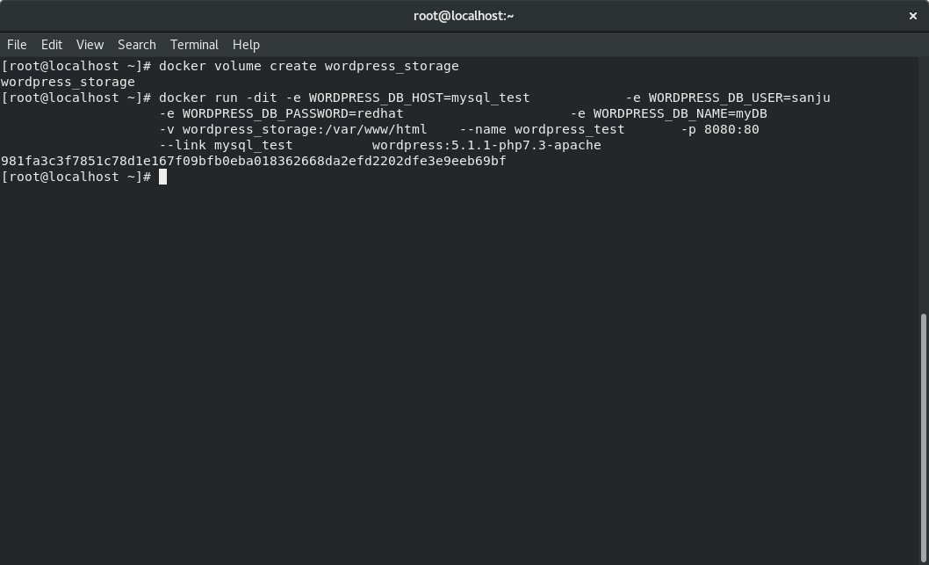

1. Now we go to Redhat and check it’s IP so we can ping that wordpress from the outside world because the concept of PAT/NAT

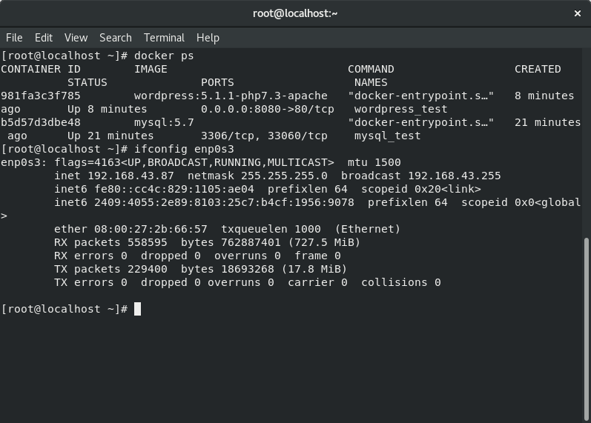

1. Now am trying to access this wordpress container from the windows by using redhat IP and port number 8080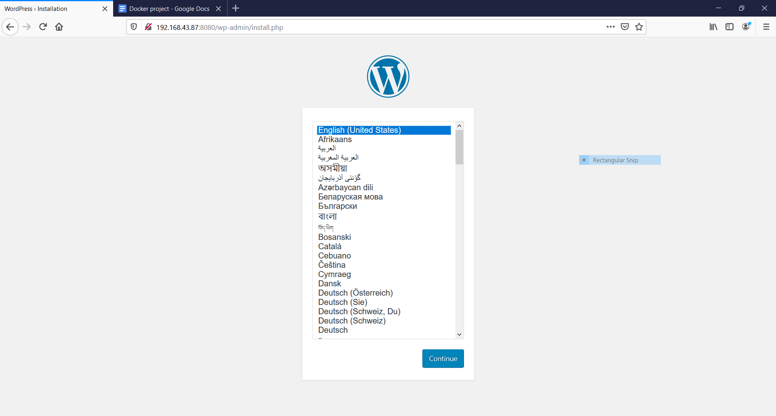

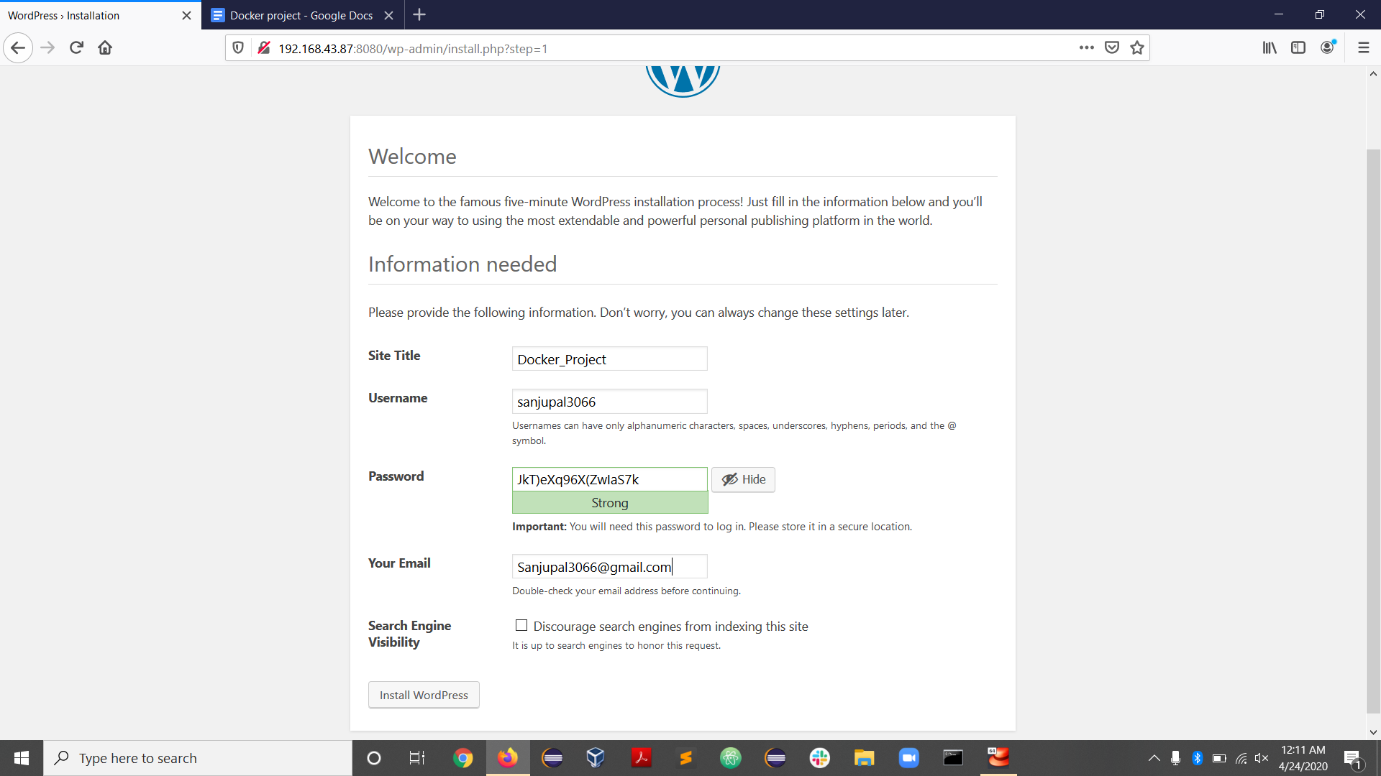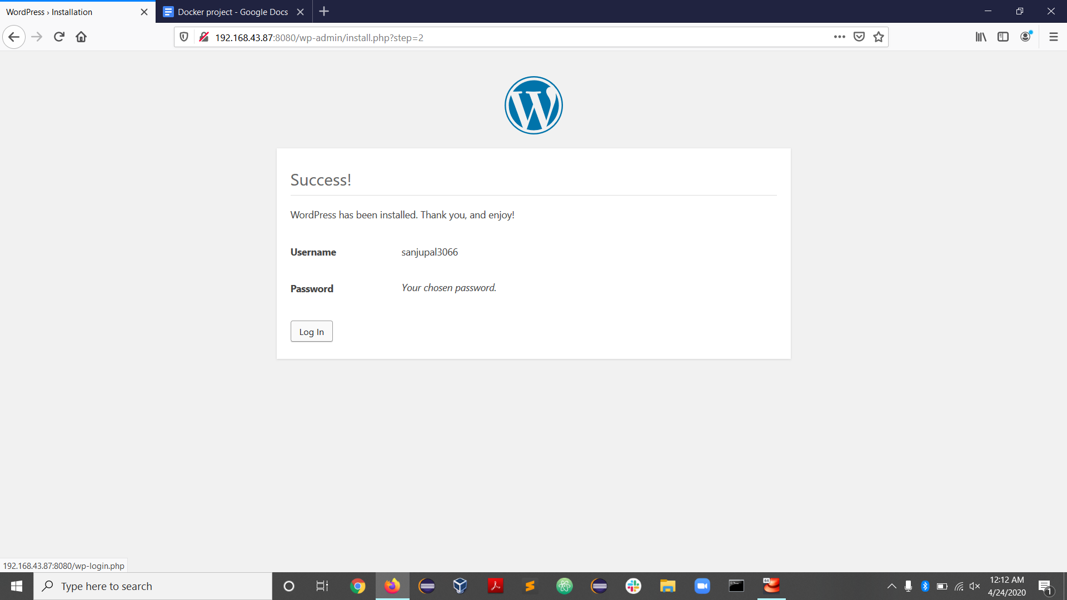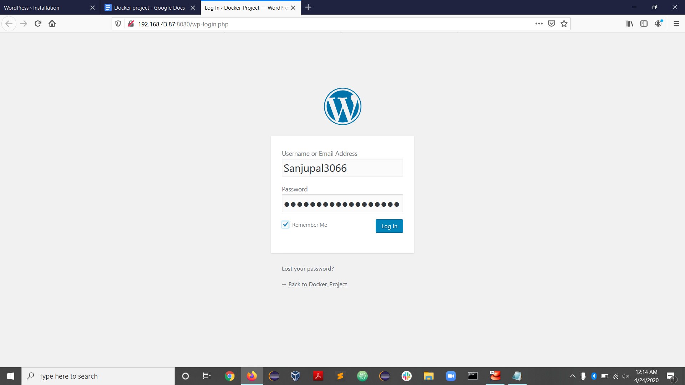

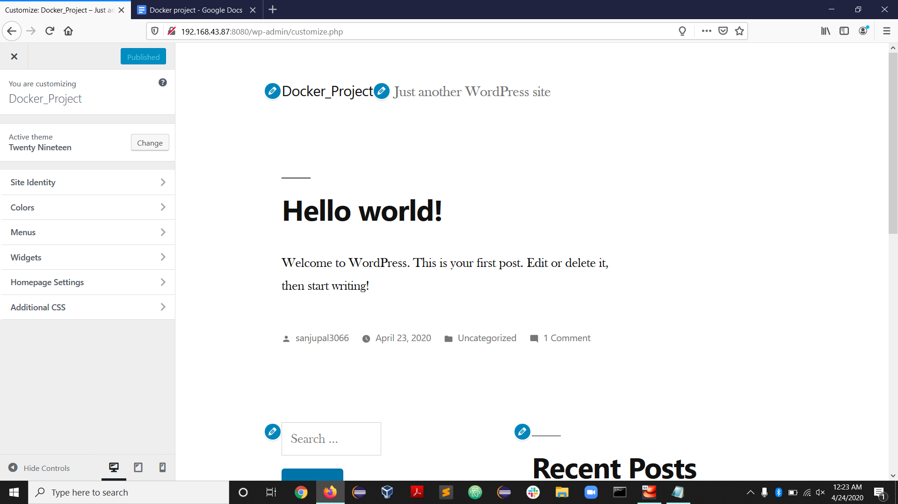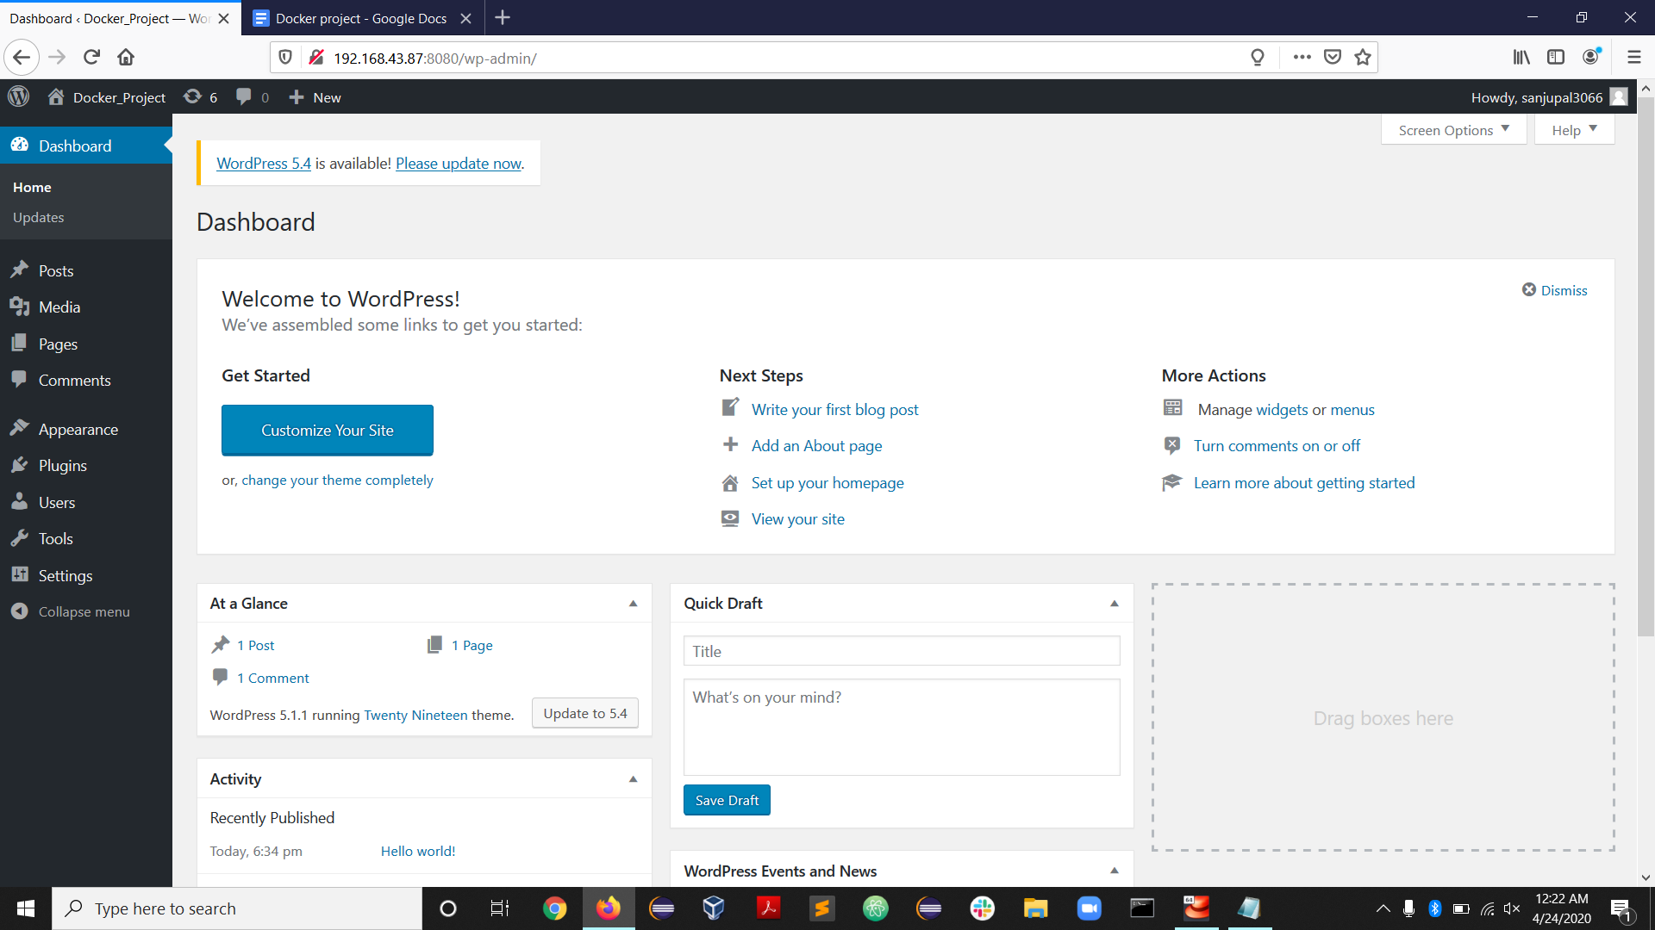

1. In this screenshot am changing the wordpress heading

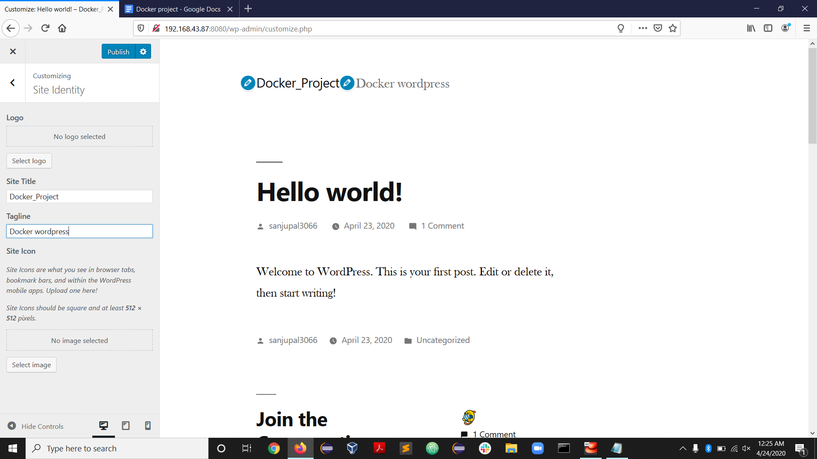

1. Now if i stop my wordpress container then this url will not work

Lets try: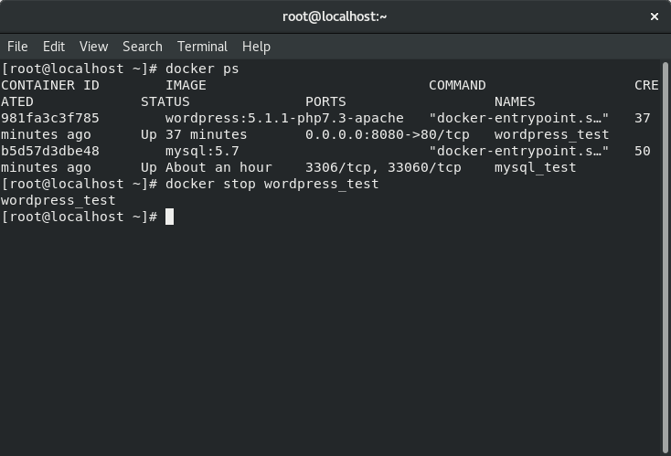

Here we can see my wordpress is not opening now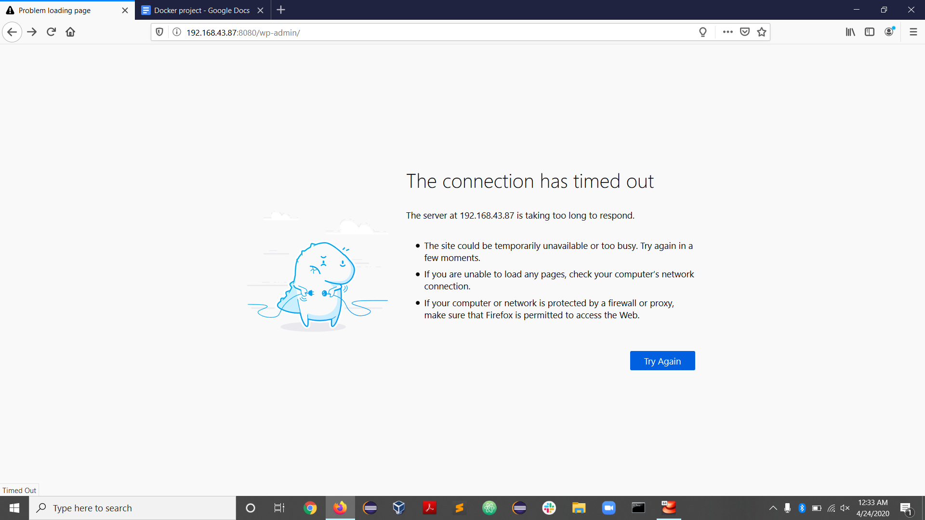

**“It's a very tedious task to check every time the server is down or not . If it's down then again write the big commands so your service is again restarted.**

**So for solving this we can use *Docker-Compose* it will load all DB and wordpress at one command”**

**Now we are creating a *Docker-Compose* file:**

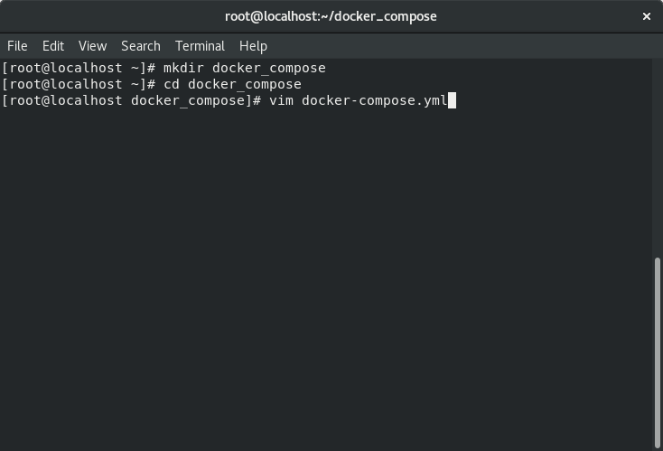

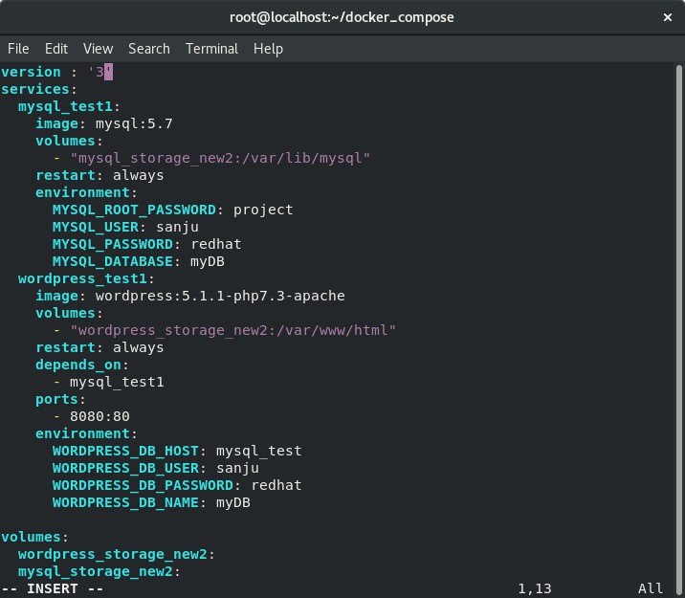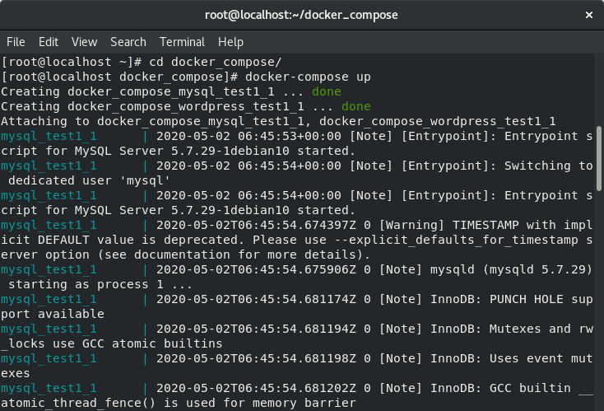

Now you can see my docker is started in just one command

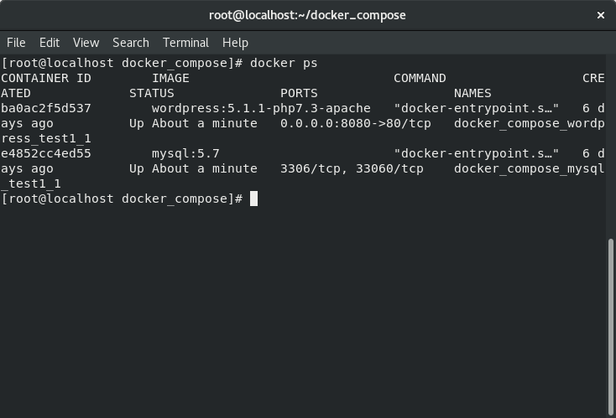

Now we are trying to access this wordpress in Windows and later we check is data is coming in DB or not

We can access wordpress by the VM IP address and then port number which we used in our file